Task 1: College Student Management System
Scenario: A college maintains student details and department details. Each student must belong to a valid department.

Table 1: Department
dept_id (PK) dept_name
101 Computer Science
102 Electronics
103 Mechanical

Table 2: Student
student_id (PK) student_name dept_id (FK)
1 Arun 101
2 Priya 102
3 Karthik 101
4 Divya 103

Tasks:
- Create a Department table with dept_id as the Primary Key.

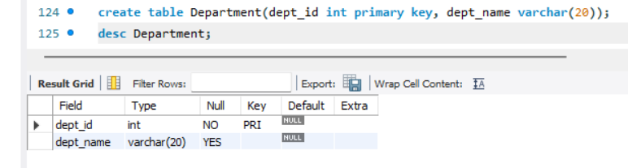

- Create a Student table with student_id as the Primary Key.
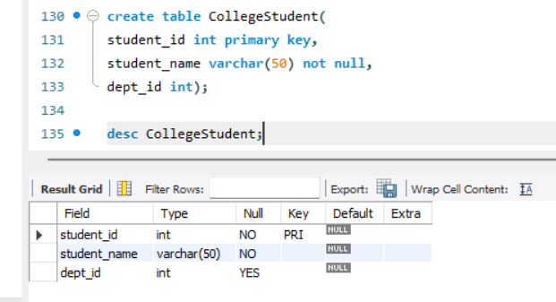
- Establish a Foreign Key relationship between Student and Department.
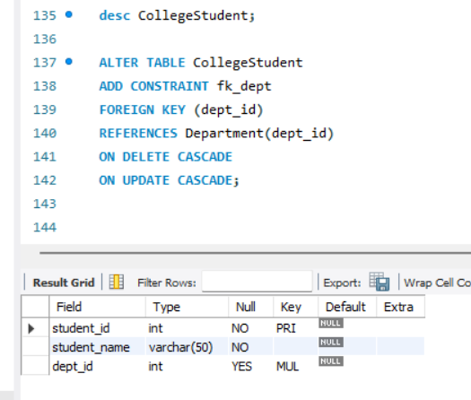
4. Insert 3 department records.
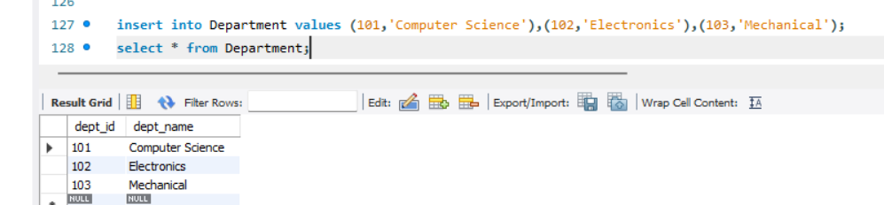
- Insert 4 student records.
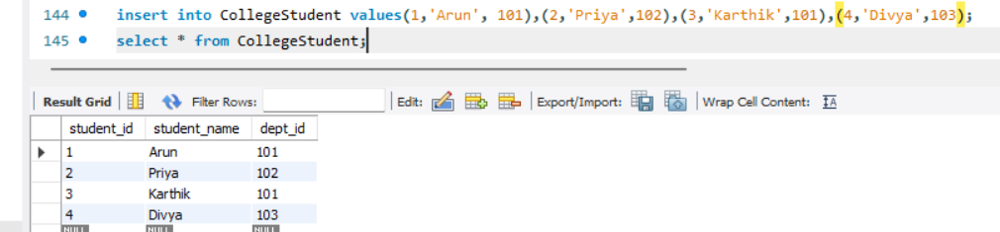
6. Try inserting a student with dept_id = 105. Observe the result.
insert into CollegeStudent values(5,'Avanthika',105) | Error Code: 1452. Cannot add or update a child row: a foreign key constraint fails (`faceprep`.`collegestudent`, CONSTRAINT `fk_dept` FOREIGN KEY (`dept_id`) REFERENCES `department` (`dept_id`) ON DELETE CASCADE ON UPDATE CASCADE)

- Display student names along with their department names using JOIN.
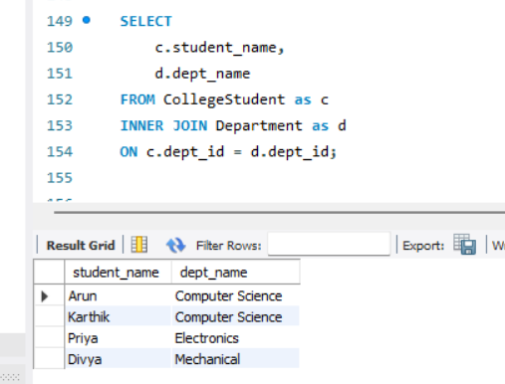
- Try deleting a department that has students assigned to it.



